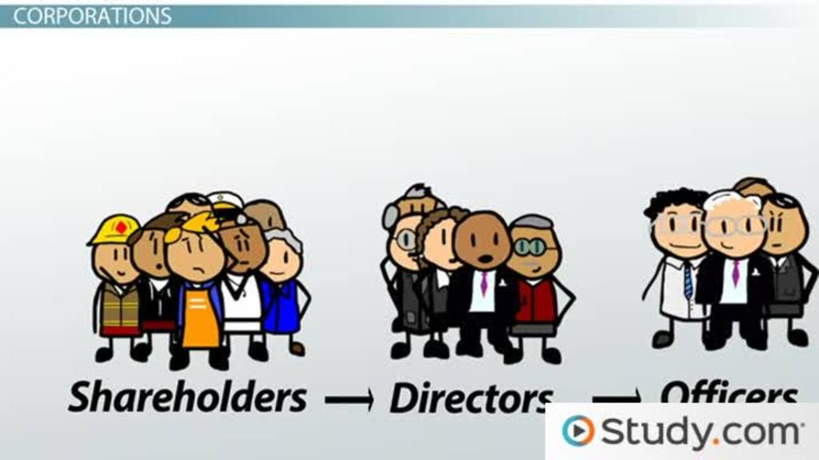

Shareholder Advocacy
- We have participated in online campaigns about stewardship of the environment – protecting Native American sacred lands from oil pipelines; speaking out against fracking and its negative consequences for the environment.
We are part of CA-CCRI, an organization of religious congregations in California that do shareholder advocacy. One area we work in is related to fossil fuels. We hold ExxonMobil and Chevron stock in order to pressure them to work to be transparent about their past knowledge of how fossil fuels contribute to climate change and urge then to develop new technologies that create alternative forms of energy that will reduce CO₂ emissions.

