**SOME RSCJ ACTIONS: SOWING HOPE FOR THE PLANET**

**Tree planting in Uganda and Kenya (photo below)**

To counter the destructive effects of cutting down trees for wood and charcoal in the places where they live, the RSCJ congregation in the province of Uganda-Kenya chose a day each year for planting trees and fruit trees in their communities and institutions. Here, a staff member plants a tree in the health clinic in Chekalini, Kenya

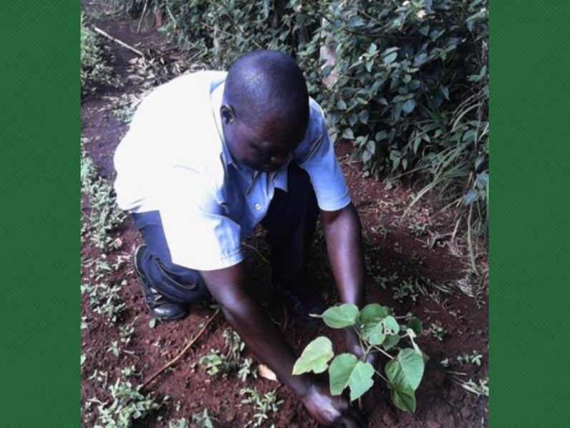

**Global Service Day (photo below)**

A group of sisters from the RSCJ generalate cleaning the garden of one of our convents near the Janiculum Hill in Rome. Throughout the world, the family of the Sacred Heart chose actions to respond to local needs. We described it as a ‘wave of grace’ around the world.

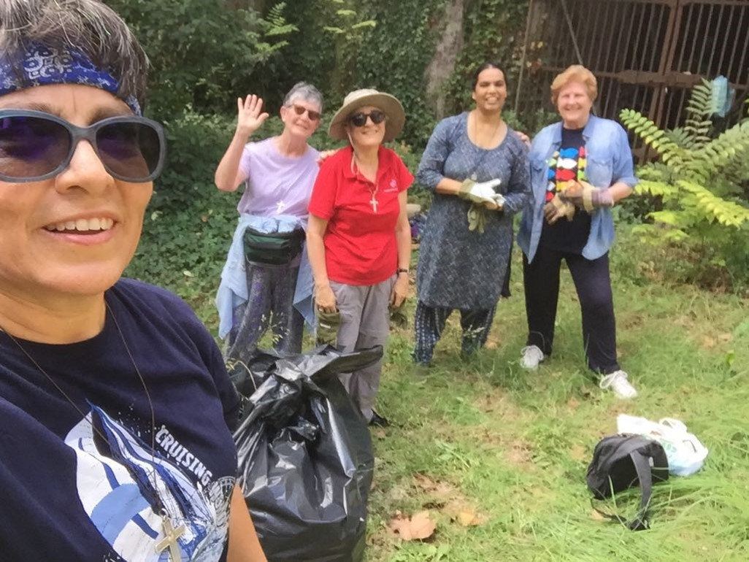

**International JPIC Meeting, The Philippines (photo below)**

At this meeting in the Philippines we identified emerging themes for JPIC in the whole congregation. One of these was ‘Caring for our Common Home’. Action plans address this theme on several levels: our personal responsibility, our educational mission, as citizens, as provinces, as an international congregation and as global citizens.

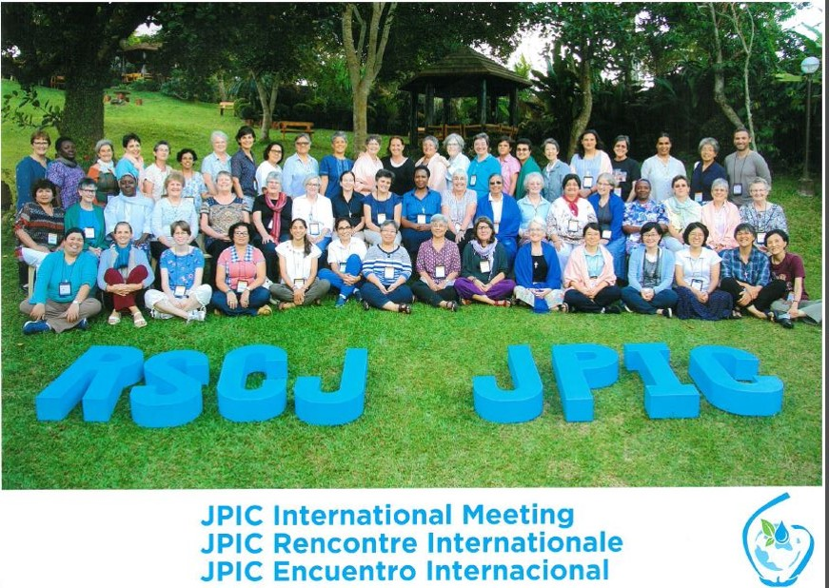

**Hogar Limpio, Santa Leticia, Colombia (photo below)**

As described in submission to the ‘Sowing Hope...’ website.

This photo shows the installation of containers with a roof covering for the newly built waste collection park.

