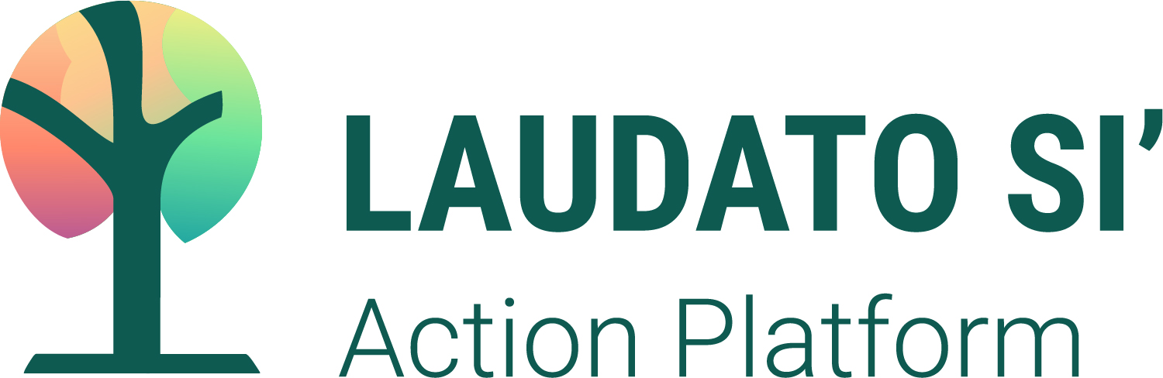

A BRIEF SUMMARY FOR LEADERS OF RELIGIOUS ORDERS

What is the Laudato Si’ Action Platform?
The Laudato Si’ Action Platform (LSAP) is “an action-oriented 7-year ecological conversion journey in the spirit of integral ecology intended to support and empower families, communities and institutions to achieve total sustainability” (Laudato Si’ Movement, 2021). This is a unique collaboration between the Vatican, an international coalition of Catholic organizations, and “all men and women of goodwill.” (LS 3) Taking a truly ground-up approach, it is rooted in the strengths and realities of communities around the world, empowering all to take “decisive action, here and now” as we journey towards a better future together. (LS 161)

The purpose of this seven year journey is to respond to the cry of the Earth, the cry of the Poor, and the cry of the children and future generations. It addresses the climate crisis - and intersecting political and economic crises - with an integrated approach to Care for Our Common Home. The IPCC’s Sixth Assessment Report, released in 2021, reminds us that we carry the burden of harm and can also act for change:

Human-induced climate change is already affecting many weather and climate extremes in every region across the globe...From a physical science perspective, limiting human-induced global warming to a specific level requires limiting cumulative CO² emissions, reaching at least net zero CO² emissions, along with strong reductions in other greenhouse gas emissions.

How are Religious Orders involved with the LSAP?
The platform convenes action from seven sectors on seven goals with a working group focused specifically on the Religious Orders sector. The working group, with members from around the world, is helping to guide, engage, and accompany the involvement of men and women religious. The LSAP was initiated by the Dicastery for Promoting Integral Human Development and has the support of UISG and USG.
The platform process recognizes that religious congregations and institutes are organized in a number of different ways, have different charisms, ministries, and geographic locations. For the purposes of the platform, the involvement can come at any dimension of religious life and ministry.

The decision making, responsibility, and reporting over the lifecycle of the project or program may happen at different levels of the congregation. The important thing is that communication happens across the congregation, within the context of the charism and spirituality of the congregation, and with the LSAP itself so that the work for integral ecology is integrated and robust while also respecting the principle of subsidiarity.

Consider these suggested steps to begin a conversation within your congregation:
- Review the platform itself: www.laudatosiactionplatform.org.
- Access educational resources like the JPIC Workshop on Thinkific and Sowing Hope for the Planet where the religious sector has shared information in preparation for the LSAP.
- Determine at what levels of governance, geography, and activity is best for your congregation. In a larger congregation, there could be multiple projects and points of involvement.
- Discern how you will proceed with raising project or program ideas. This could be through theological reflection, listening sessions, the see/judge/act cycle, or with other tools for communal discernment.
- Decide if there is a need for one person at the congregation to connect across all projects and programs and to serve as the person who collects these plans to enter into the platform.
- When you have conducted the discernment, briefly outline the proposed projects, programs, or activities in the form of a public commitment to the journey of integral ecology. An example for religious congregations is available on Sowing Hope for the Planet.
- On November 14, enroll in the platform on the website.
- Use your internal communication outlets to engage your congregation in the LS work. Use your external communication outlets to invite others to accompany you or to raise awareness about the journey.
- Create a possible timeline as an aid for revisiting your actions: Monthly, quarterly, annually, and at your congregation’s reporting and gathering periods: chapters, assemblies, etc.
How will the platform assist Religious Orders in their journey?
The Laudato Si’ Action Platform will provide Planning Guides for participants to create their own Laudato Si’ Plans. These planning guides will include three key steps: reflecting, acting, and evaluating/celebrating along with the See, Judge, and Act methodology These steps are suggestions, and they will be used by participants in the way that works best for them. The planning guide is offered as a way to support and empower participants, but is not definitive or mandatory by any means. An overview of Laudato Si’ goals and actions is now available on the LSAP platform site here.

The first step in the planning guide, reflection, will encourage participants to prayerfully consider how the Laudato Si’ Goals are connected to their mission and values (charism), to develop a nuts-and-bolts process for how they will take action, and to create a list of stakeholders who should be involved every step of the way.
Questions? Contact: jpicroma@gmail.com

https://laudatosiactionplatform.org/
https://www.ipcc.ch/report/ar6/wg1/downloads/report/IPCC_AR6_WGI_SPM.pdf
https://laudatosiactionplatform.org/laudato-si-goals/
https://laudatosiactionplatform.org/community/
https://www.humandevelopment.va/en.html, http://www.internationalunionsuperiorsgeneral.org/, https://www.usgroma.org/en/
Access via https://jpic-workshop.thinkific.com/users/sign_in. Request enrollment by sending an email to: jpicroma@gmail.com. Sowing Hope for the Planet is available here: https://www.sowinghopefortheplanet.org/
https://www.sowinghopefortheplanet.org/files/shftp_uploads/2021/9/LSAPComm_EN.pdf
https://laudatosiactionplatform.org/app/uploads/2021/05/overview-of-laudato-si-goals-and-actions.pdf

