September 29, 2021
Dear Major Religious Superior
Thank you for considering and developing a Laudato Si’ Plan for your Congregation. You give hope to all who look for signs of change as we face this ecological crisis. This step in your path is cause for celebration: Laudato Si’!
As the Major Superior of your Congregation, you are invited to encourage the involvement of your religious and your ministerial connections. Your support is important for the fruitfulness of the program. If you have not yet made your commitment, the Laudato Si’ Action Platform Commitment Statement for Religious may be helpful in your prayer ritual. (See statement included in this mailing.)
At the end of the Season of Creation, on October 4th, we will be asked to engage in 40 days of preparation to discern whether to enroll into the LSAP on November 14th, 2021. This journey will be for 7 years. Prayers and resources will be available on the www.laudatosiactionplatform.org and https://www.sowinghopefortheplanet.org
There are four main domains that are encouraged in a focused commitment by the leadership of Congregations involving their communities:
- Animating and accompanying local communities in their efforts towards integral ecology.
- Promoting opportunities for the personal formation of religious members.
- Providing financial resources and support to engage in, for example, alternative energy plans and new investment strategies.
- Developing policies and guidelines essential to sustainable ecology.
It is recommended that each Congregation name a Laudato Si’ Contact Person(s) who will promote the overall process of actualizing the LSAP. They will provide coordination, facilitation, and reporting of engagement and implementation. This work will need support and will be considered a team effort. Pope Francis calls us to “an ‘ecological conversion’, whereby the effects of [our] encounter with Jesus Christ become evident in [our] relationship with the world around [us].” (LS 217)
Congregations are gifted with charisms to live the Gospel by engaging in the LSAP. With our own planning, actions, and attitudes we hope to bring about a global conversion to ‘total sustainability in the spirit of integral ecology’. Pope Francis reminds us: “Social problems must be addressed by community networks and not simply by the sum of individual good deeds.” (LS 219) We need networks strong enough for systemic change. Through the practice of nonviolence, we heal the pain in creation and sow hope for peace.
All are invited to participate in this platform. The more we can find ways to work together, the stronger will be our contribution, for ‘everything is connected’. “By developing our individual, God-given capacities, an ecological conversion can inspire us to greater creativity and enthusiasm in resolving the world’s problems and in offering ourselves to God ‘as a living sacrifice, holy and acceptable’ (Rom 12:1)” (LS 220).

Thank you and united in prayer,
  Sr. Sheila Kinsey, FCJM  Coordinator, Sowing Hope for the Planet | 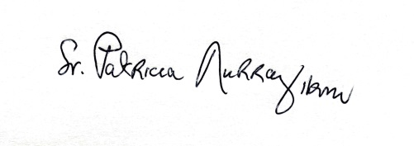  Sr. Patricia Murray, IBVM  Secretary General UISG | 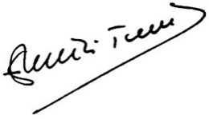  Br. Emili Turú Rofes, FMS  Secretary General USG

